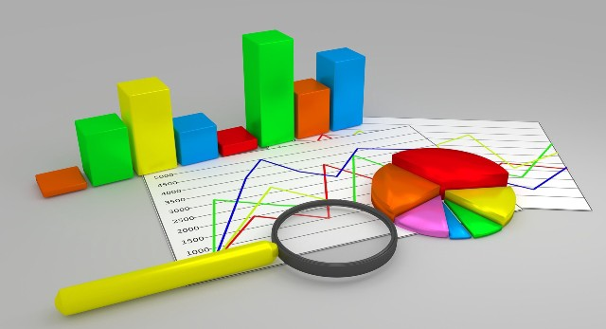

**Group Members (Group # 8):**

**Ali Khalid MSDS21001**

**Muhammad Ahmad MSDS21021**

**Muhammad Tayyab MSDS21032**

**Haider Ali Adeel MSDS21044**

Citation Analysis of Pakistani Researchers in the Field of Data Science

**Data Collection: Report**

Data is collected from Web of Knowledge also known as Web of Science, Clarivate Analytics. Web of Science is a website that provides subscription-based access to multiple databases that provide comprehensive citation data for many different academic disciplines. It was originally produced by the Institute for Scientific Information and is currently maintained by Clarivate Analytics.

Using advanced search from Web of Knowledge, we collected data using the following Query

**Query:**

**QU= (PAKISTAN) AND SU= (Computer Science)**

**Indexes = SCI-EXPANDED, SSCI, A&HCI, ESCI**

**Timespan = (All years)**

The abbreviated terms in Query represents CU as Country/Region, SU as Research Area, SCI_EXPANDED as Science Citation Index Expanded, SSCI as Social Science Citation Index, AHCI as Arts Humanities Citation Index, ESCI as Emerging Sources Citation Index.